NewGL Planning with Profit Center Combination

12 Likes 4,908 Views 10 Comments

Planning function in General Ledger Accounting is use to have forecast values for Profit & Loss GL Account & Balance Sheet Accounts. Planning can be done with combination of Profit Centers against GL Accounts for a given period or for a particular fiscal year.

**Steps:**

[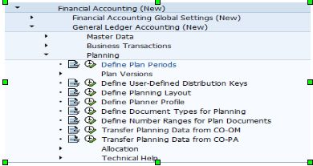](https://blogs.sap.com/wp-content/uploads/2012/11/img_path_158223.jpg)

A) Plan Periods:

Plan Period determines the posting periods allowed for entering plan data. Plan periods are assigned to Co. Codes.

[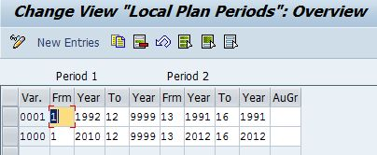](https://blogs.sap.com/wp-content/uploads/2012/11/plan_period_158224.jpg)

B) Plan Versions:

Multiple Plan Versions can be created for comparision of Plan datas.

[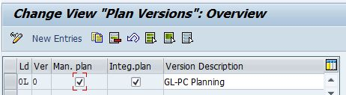](https://blogs.sap.com/wp-content/uploads/2012/11/plan_version_158231.jpg)

C) Assign Plan Versions to Fiscal Year & Co. Codes:

[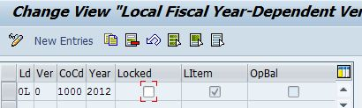](https://blogs.sap.com/wp-content/uploads/2012/11/plan_version_158232.jpg)

D) Activation of Line Item Planning: Activation is required for updating plan values in***“*FAGLFLEXP/FAGLFLEXT”** table.

[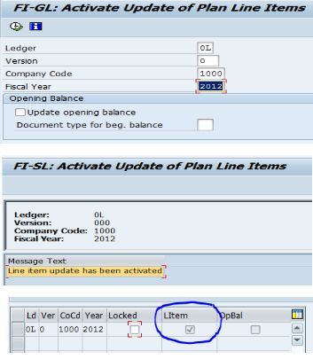](https://blogs.sap.com/wp-content/uploads/2012/11/act_158233.jpg)

E) Creating Planning Profile: Planning Profile defaults the parameters for which planning is to be done. Before executing any GL Planning Planner Profile is mandatory to be assigned.

Standard Planning Profile **“SAPFAGL – Planner Profile for Planning in Gen. Ledger (New)”** can be copied for creating Client specific Planning Profile.

Before creating Planner Profile – GL Tables needs to be activated as below:

Tcode: GLPLINSTALL

[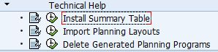](https://blogs.sap.com/wp-content/uploads/2012/11/act_158237.jpg)

[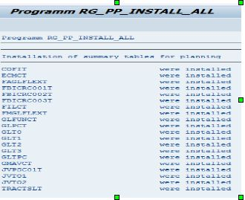](https://blogs.sap.com/wp-content/uploads/2012/11/1_158238.jpg)

[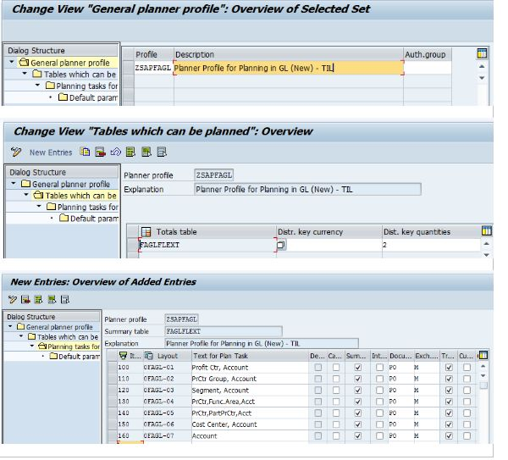](https://blogs.sap.com/wp-content/uploads/2012/11/1_158239.jpg)

F) Document Type for Planning:

[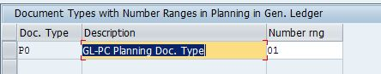](https://blogs.sap.com/wp-content/uploads/2012/11/1_158249.jpg)

G) Number Ranges for Plan Documents:

[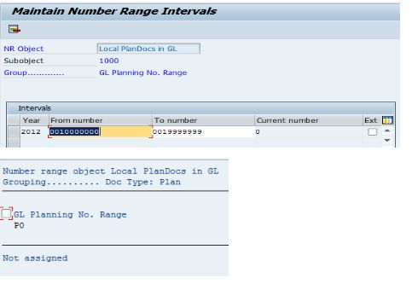](https://blogs.sap.com/wp-content/uploads/2012/11/1_158250.jpg)

Above steps are the Configuration part for GL Planning with Combination of Profit Center.

**TRANSACTION CODE FOR GL PLANNING:**

**[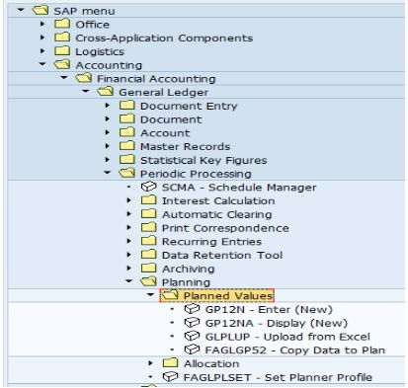](https://blogs.sap.com/wp-content/uploads/2012/11/1_158251.jpg)**

For Setting Planner Profile Default:

[1.JPG](https://blogs.sap.com/wp-content/uploads/2012/11/1_158258.jpg)

[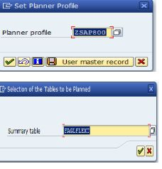](https://blogs.sap.com/wp-content/uploads/2012/11/1_158259.jpg)

Execute T Code: GP12N

[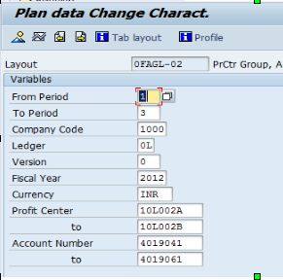](https://blogs.sap.com/wp-content/uploads/2012/11/1_158260.jpg)

Enter the Plan Values:

[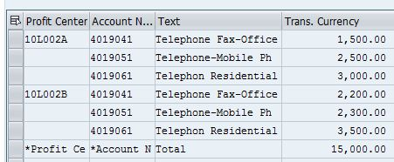](https://blogs.sap.com/wp-content/uploads/2012/11/1_158267.jpg)

Document would get generated.

Table:

FAGLFLEXP/

FAGLFLEXT

gets updated with Record Type:1

[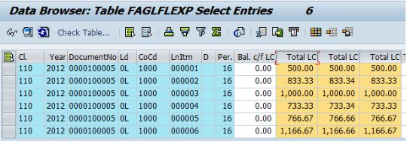](https://blogs.sap.com/wp-content/uploads/2012/11/1_158268.jpg)

**Report for Plan Vs. Actual:**

S_PL0_86000029